CAPS and T&E Combined Training Calendar

Project Scope:
-Both the CAPS and Training and Education departments require that adjusters complete specific training in preparation for system releases and company-wide changes to handling. Instead of maintaining their own training schedules separately, a combined calendar was proposed as a collective inclusive resource for liability directors.

Requirements:
-Simple straight-forward interface able to manage many users while providing all functionality in one place (user doesn’t have to click around and get redirected/open new tabs to get the information they want) and minimizing training needed for new team members to submit new training items
-Centrally located while also being able to distinguish distinct permissions: read-only for claims management, contribute/edit for only relevant CAPS/T&E team members, and inaccessible by anyone else
-Start and End Dates for training, region and claim level being trained, type and length of training
-Distinguish 3 phases of the same training: Train the Trainer, period for regional training of adjusters, and implementation date of roll-out

Brainstorming:
-CAPS originally proposed organizing this information with Excel. While this allows more flexibility with customization and fine details, there were limitations including:
-loading delays
-multiple users accessing a file on a share drive
-managing permissions
-all events were organized in a list format instead of plotted on a unified simple-view calendar
-learning curve of proprietary system for new users instead of clean fool-proof submission form and toggling filters/tabs to see desired data
-questionable ownership and know-how for future updates/maintenance

-SharePoint was proposed by T&E management as a company-wide accepted and accessible platform primarily due to its existing use for organizing the T&E Training Implementation schedule; however, concerns were brought up regarding its limitations:
-calendar view only showing 3 items concurrently requiring user to “expand all” in order to see full list of events
-color-coordinating the different phases of the training, from initial train-the-trainer to regional training periods to implementation for scoring purposes
-ability to easily and quickly personalize the training events per region and claim level applicable to each manager/director to maximize efficiently and relativity

Obstacles and Solutions:
-SharePoint Calendar app turned out to be undesirable due to the many default yet valueless fields that populated on the new item form. Additionally, the number of unique views required to display specific regional/claim level pairing proved problematic, particularly because of the limitation of 9 views available in a calendar overlay.

-SharePoint list was created with only the fields necessary

-148 individual views were made to accommodate all combinations of pairings for 16 claim offices with 8 adjuster levels plus an overall view for each office, as well as an all-inclusive calendar for all claims

-To generate a clean central hub interface that would accommodate the intuitive ability to personalize the training schedule while not requiring re-directs or navigate the user off-page, a wiki-page enhanced with CSS and JavaScript would serve as a complete landing and hosting page. View the components below:

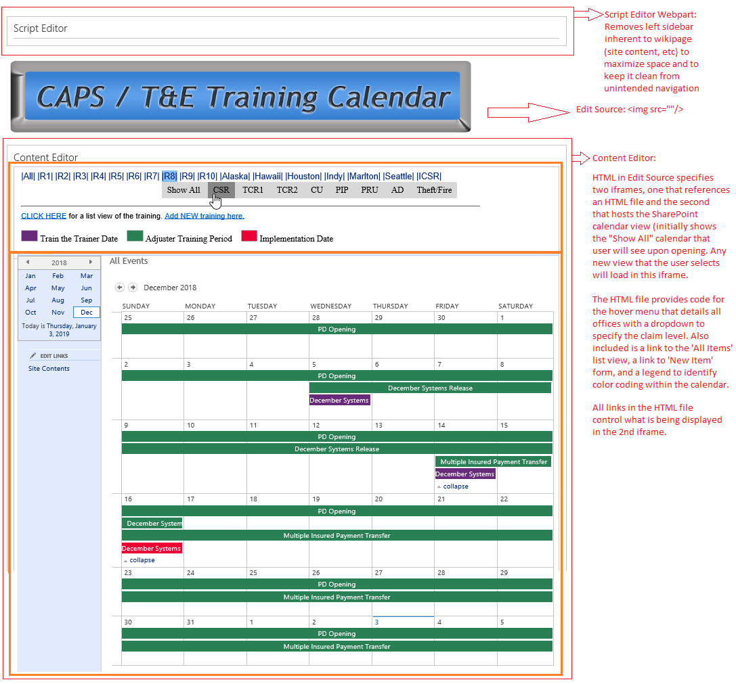

Content Editor Code:

<div style="margin: -20px 1px 1px 5px; text-align: center; overflow: hidden; max-width: 855px;">
<iframe name="DropdownCalendar" src="/sites/csr/State%20Maps%20HTML/DropdownCalendar.html" scrolling="no" style="border: 0px currentcolor; width: 900px; height: 162px; margin-top: 0px; margin-left: 0px;"> </iframe>
<p>&#160;</p>
</div>
<hr/>
<div style="margin: -20px 1px 1px 5px; overflow: hidden; max-width: 1000px;">
<iframe name="myIframe" src="/sites/CHO_TRAINING_AND_DEVELOPMENT/MGMTDevPortal/Lists/Combined%20Training/Calendar.aspx" scrolling="no" style="border: 0px currentcolor; width: 1060px; height: 1300px; margin-top: -95px; margin-left: -10px;"> </iframe>
<p>&#160;</p>
</div>

-In addition to a highly functional landing page, each of the 148 calendar view pages was modified to achieve two imperative project parameters:
-color code training types (this is generally accomplished through calendar overlays, but requires a calendar app and is limited to 9 views)
-expanded the calendar to automatically show all items (default is to limit 3 per week)

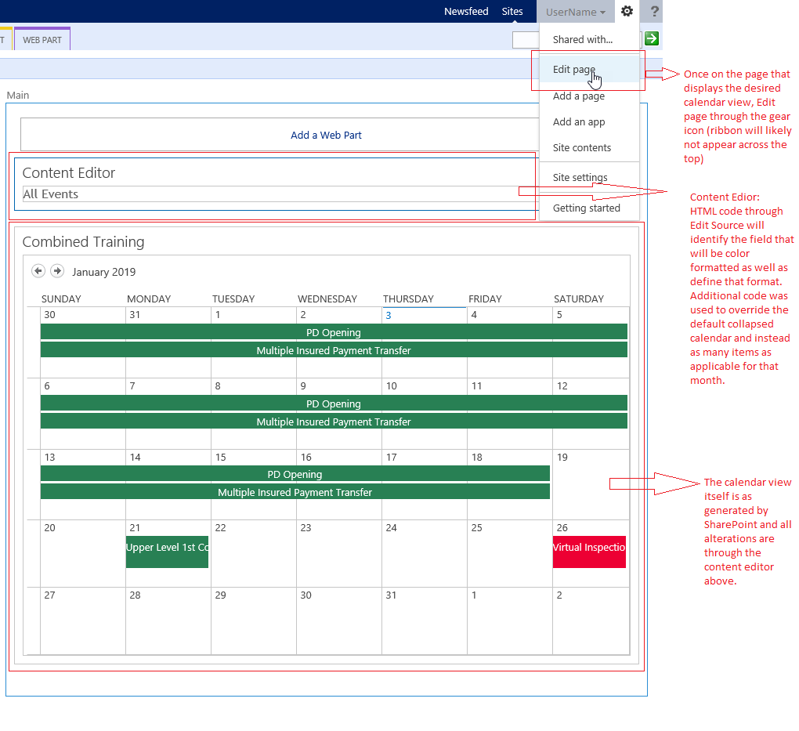

Final View:

